# **Simulation and Validation of NACA 2412 Airfoil Aerodynamics**

**Surjya Sankar Roy**, **IIT Kharagpur**

**Abstract**

This study involves a 2D steady-state CFD simulation of the NACA 2412 airfoil using ANSYS Fluent, with the aim of validating aerodynamic performance against NASA experimental data. The Transition SST turbulence model was used to simulate flow over an angle of attack range of 0°–14°, resulting in less than 7% error in both lift and drag coefficients. Mesh quality and appropriate turbulence model selection were critical in achieving reliable results.

**Objective**

The objective of this project is to simulate the aerodynamic characteristics of the NACA 2412 airfoil and validate the results against NASA experimental data. The focus is on selecting an appropriate turbulence model and generating a high-quality mesh to ensure accurate prediction of aerodynamic forces.

**Methodology**

The simulation was conducted on a 2D NACA 2412 airfoil with a chord length of 1 meter. A C-type computational domain was created, where the radius of the semicircular inlet boundary was set to 7.5 times the chord length, and the outlet boundary was placed 10 times the chord downstream. The airfoil’s nose was positioned at the center of the semicircle.

A structured mesh was generated for the C-type domain with higher refinement near the airfoil surface and in the wake region. Special attention was given to the trailing edge to capture flow separation accurately. The mesh was refined to maintain a non-dimensional wall distance (y⁺) below 1, ensuring proper resolution of the boundary layer with the Transition SST model. The total mesh contained approximately 170,000 cells, and mesh quality checks confirmed low skewness and high orthogonality. **Figure 1** shows the final mesh, highlighting refinement near the surface and in the wake zone.

The Reynolds number was set to 3.1 million, matching the conditions of NASA's experimental tests. With an air viscosity of 1.802 × 10⁻⁵ kg/m·s, the corresponding freestream velocity was calculated to be 45.6 m/s. Boundary conditions included a velocity inlet, pressure outlet set to atmospheric pressure, and a no-slip condition on the airfoil surface. No symmetry boundary was applied.

Several turbulence models were tested. The Spalart–Allmaras and k–ω SST models resulted in 15–20% error in predicting aerodynamic coefficients. The Transition SST model, however, provided consistent accuracy across the angle of attack range, and was therefore selected for the final simulations.

A pressure-based, steady-state solver was used for all simulations. Default discretization schemes were applied. Mesh quality was carefully controlled, maintaining a y⁺ value below 1 and refining the trailing-edge region to accurately resolve boundary layer effects.

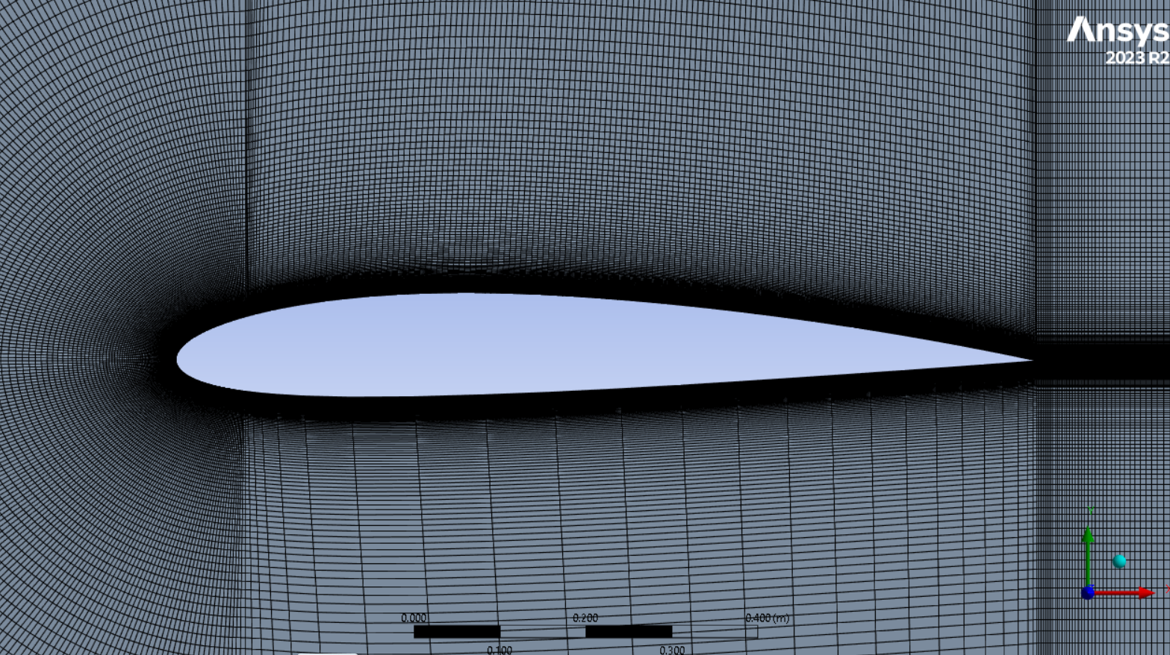

**Figure 1: Structured mesh around NACA 2412 airfoil with refined trailing edge and boundary layer resolution**

**Results & Validation:** Table 1 presents the comparison of lift and drag coefficients obtained from simulation using the Transition SST model with NASA experimental data, along with the percentage deviation at each angle of attack.

|  |  |  |  |  |  |  |  |  |
| --- | --- | --- | --- | --- | --- | --- | --- | --- |
| |  | | --- | | **AoA (°)** |  |  | | --- | |  | | **Cl (Sim)** | **Cl (NASA)** | **Cl_error(%)** | **Cd (Sim)** | **Cd (NASA)** | **Cd_error(%)** |
| 0 | **0.231** | **0.22** | **4.5** | **0.0058** | **0.006** | **3.3** |
| **2** | **0.436** | **0.45** | **3.28** | **0.0078** | **0..0075** | **4** |
| **4** | **0.665** | **0.65** | **2.3** | **0.00712** | **0.0068** | **4.49** |
| **6** | **0.873** | **0.85** | **2.7** | **0.009125** | **0.0091** | **0.3** |
| **8** | **1.069** | **1.05** | **1.8** | **0.0119** | **0.0115** | **3.47** |
| **10** | **1.267** | **1.24** | **2.18** | **0.1385** | **0.135** | **2.59** |
| **12** | **1.45** | **1.4** | **3.44** | **0.0169** | **0.0162** | **4.14** |
| **14** | **1.6** | **1.5** | **6.7** | **0.0222** | **0.023** | **3.47** |

**Table 1: Comparison of Simulated and NASA Experimental Cl and Cd Values for NACA 2412 Across Various Angles of Attack**

**Figure 2: Cl vs AoA — Simulated vs NASA Data**

**Figure 3: Cd vs AoA — Simulated vs NASA Data**

**Conclusion**

The CFD simulation of the NACA 2412 airfoil using the Transition SST model successfully validated lift and drag predictions against NASA experimental data. The final setup achieved less than 7% error across the 0°–14° angle of attack range. Proper mesh refinement and turbulence model selection were essential in ensuring high simulation fidelity.

**References**

* [**Abbott, I.H., & Von Doenhoff, A.E. *Theory of Wing Sections*. NASA Technical Report**](https://ntrs.nasa.gov/citations/19930090976)